SIMATS ENGINEERING
NAME: A.Preetika Sudhakar
RREG NO. 192371073
COURSE NAME: Database Management Systems
COURSE CODE: CSA0501

Ex. No.: 7
SELECT with GROUP BY, HAVING, ORDER BY
AIM:
To view the records from the tables using SELECT commands with Group By, Having, Order By
DESCRIPTION:
GROUP BY – HAVING:
➢ The GROUP BY clause groups a set of rows into a set of summary rows by values of columns or expressions. The GROUP BY clause returns one row for each group. In other words, it reduces the number of rows in the result set.
➢ The GROUP BY clause is used with aggregate functions such as SUM, AVG, MAX, MIN, and COUNT. The aggregate function that appears in the SELECT clause provides the information about each group. ➢ The GROUP BY clause is an optional clause of the SELECT statement.
➢ To filter the groups returned by GROUP BY clause, you use a HAVING clause.
SYNTAX:
GROUP BY – HAVING:
SELECTc1, c2,...,cn, aggregate_function(ci)
FROMtable
WHEREwhere_conditions
GROUP BYc1 , c2,...,cn
HAVINGconditionS
ORDER BY:
SELECT column1, column2,...
FROMtbl
ORDER BY column1 [ASC|DESC], column2 [ASC|DESC],...

GROUP BY & HAVING:
1. How many plots are available in each location?
SELECT location, COUNT(*) AS total_plots FROM plots GROUP BY location;
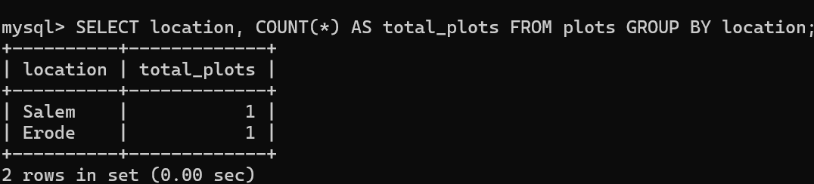

2. How many plots does each owner have?
SELECT owner_id, COUNT(*) AS total_plots FROM plots GROUP BY owner_id;
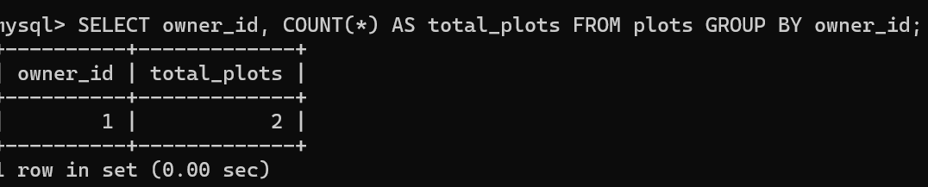

ORDER BY

3. Display plot number, status and location in ascending order of plot_id
SELECT plot_no, status, location FROM plots ORDER BY plot_id ASC;

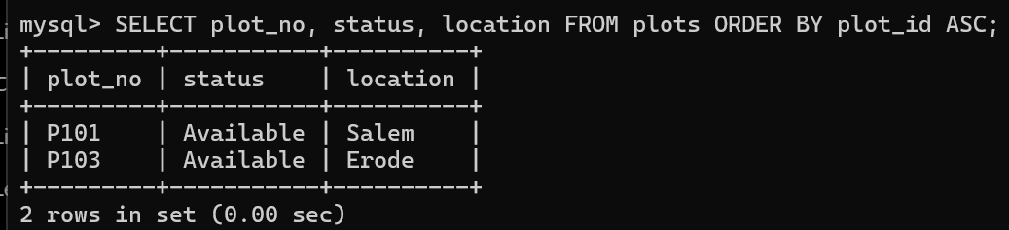

4. Display plots in the order of highest price first
SELECT * FROM plots ORDER BY price DESC;
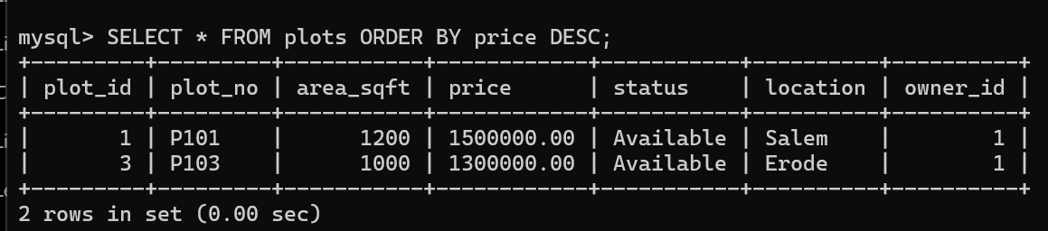

RESULT:
The records from the tables are displayed using SELECT commands with GROUP BY, HAVING and ORDER BY.

